ESS 421 January 19, 2011

Lab # 3: Atmospheric Compensation

Due at beginning of Lab on Wednesday, January 26th.

Some definitions:

Absorption - atmospheric absorption is defined as a process in which solar radiation is retained by a substance and converted into heat energy. The creation of heat energy also causes the substance to emit its own radiation.

Scattering - is an atmospheric process where small particles and gas molecules diffuse part of the incoming solar radiation in random directions without any alteration to the wavelength of the electromagnetic energy. Scattering does, however, reduce the amount of incoming radiation reaching the Earth's surface. A significant proportion of scattered shortwave solar radiation is redirected back to space. The amount of scattering that takes place is dependent on two factors: wavelength of the incoming radiation and the size of the scattering particle or gas molecule. In the Earth's atmosphere, the presence of a large number of particles with a size of about 0.5 µm results in shorter wavelengths being preferentially scattered. This factor also causes our sky to look blue because this color corresponds to those wavelengths that are best diffused.

Emission - process of radiation of electromagnetic energy by a body. Emission is determined by kinetic temperature and emissivity.

Emissivity - ratio of radiant flux from a body to that from a blackbody at the same kinetic temperature.

Path radiance - directional radiation scattered into the camera from the atmosphere without touching the ground.

Electromagnetic spectrum - the entire range of radiant energies or wave frequencies from the longest to the shortest wavelengths - the categorization of solar radiation. Satellite sensors collect this energy, but what the detectors capture is only a small portion of the entire electromagnetic spectrum. The spectrum usually is divided into seven sections: radio, microwave, infrared, visible, ultraviolet, x-ray, and gamma-ray radiation (Figure 1).
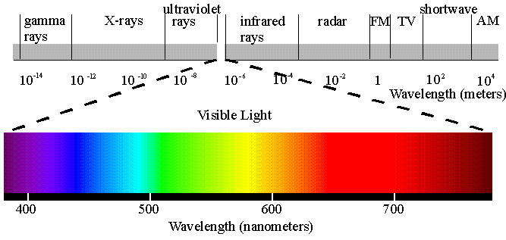

Figure 1. Electromagnetic spectrum

Coincidentally or through evolution, the visible region of electromagnetic spectrum lies in a relatively transparent region of the atmosphere where radiant emission from the sun is peaked. Figure 2 shows spectral irradiance of the sun at the top of the atmosphere and after transmission through atmosphere; as illustrated the solar curve is peaked at 0.5 µm (0.5*10⁻⁶ m). The figure also illustrates how the intensity of solar irradiation is reduced by scattering and absorption as it passes through the atmosphere.
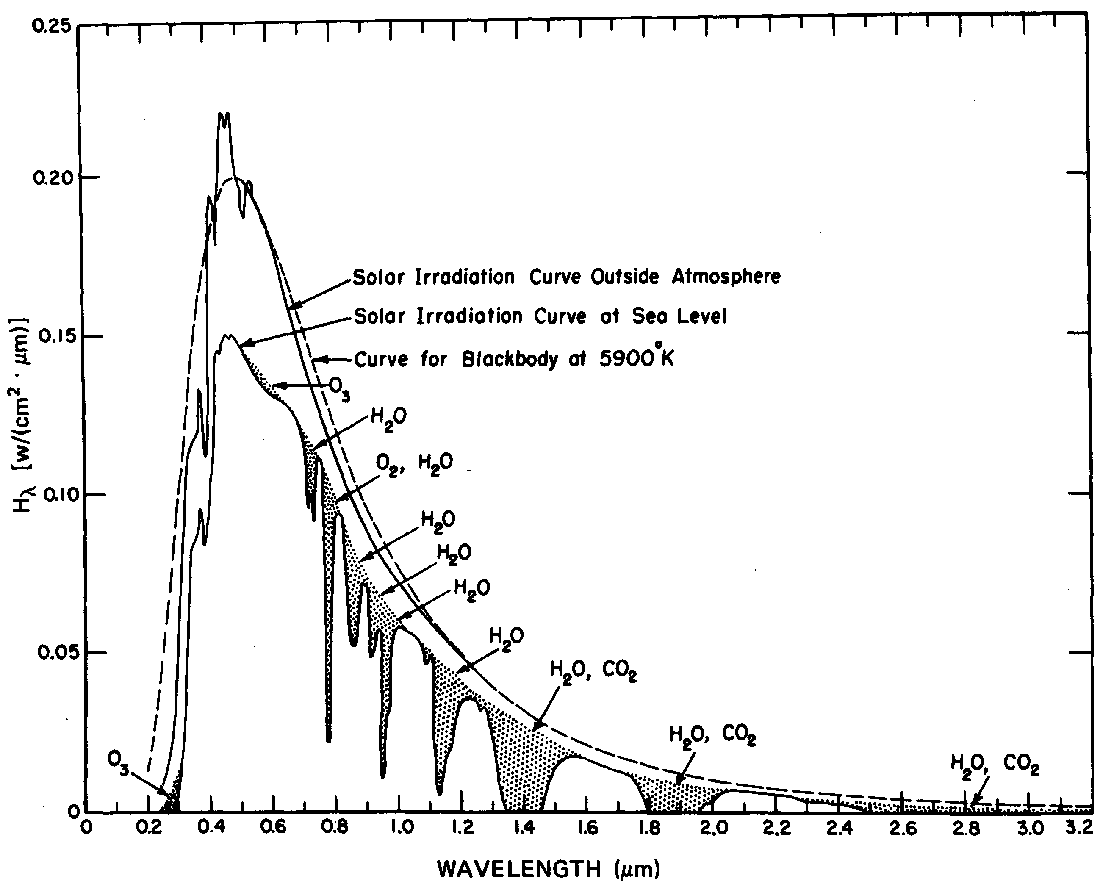

Figure 2. Solar spectral irradiance
There are no serious limitations to solar energy or atmospheric absorption in visible wavelengths. In operating at longer wavelengths, in the infrared and microwave, it is necessary to use regions called windows, where the atmosphere is relatively transparent. Figure 3 illustrates expected atmospheric transmittance in different wavelengths.

One important tool in understanding the effects of atmospheric absorption, scattering and emission is a physically based radiative-transfer model such as MODTRAN. MODTRAN enables one to specify an atmosphere (characterized by water vapor, pressure and temperature profiles) and estimate atmosphere correction parameters for it - parameters like atmospheric transmissivity (transmittance), path radiance, and downwelling sky irradiance.

This lab consists of several parts. We don't have the (expensive) licenses to install MODTRAN on the lab computers, but we can give you the output data. If you are interested in the model, a tutorial "PC MODTRAN Tutorial " is available as a resource at http://staff/washington.edu/lgilson/Tutorials.shtml, but reading it is optional.

In the lab work, you will work with data generated by MODTRAN to explore the spectra of atmospheric parameters in the VNIR (visible, near infrared) versus the TIR (thermal infrared) wavelength regions. To analyze the data, you can use Excel or whatever data analysis package you are comfortable with. A tutorial for Excel ("Excel Tutorial) is available if you want to consult it.

PART I: Compare VNIR transmissivity for ‘standard’ and ‘tropical’ atmosphere models.

The datasets we will use are available from the web. Start a web browser and point it at: http://staff.washington.edu/lgilson/labs421/Lab_3/. Open the file "lab3-partI.xls" and download it to the local machine. Open Excel (using the Start Menu) and then open the file lab3-partI.xls. You will be using both the US Model and Tropical worksheets (indicated on the tabs at the bottom of the work space). US Model refers to the US Standard Model 1976 atmosphere.

There should be a plot of the transmissivity spectrum in the VNIR (0.4 to 2.9 µm). For reference-- absorption in the ultraviolet is due to ozone; the big absorption features are due to water in the air; and the fall-off in the SWIR is due to atmospheric water. If you place the mouse at the appropriate spot on the plot a window giving the data values will pop up.

QUESTION 1:
U.S. model Tropical model
a) What is the transmissivity at about 1.06 µm? ___________ ___________
b) What is the transmissivity at about 0.94 µm? ___________ ___________
c) What is the transmissivity at about 1.39 µm? ___________ ___________
QUESTION 2:

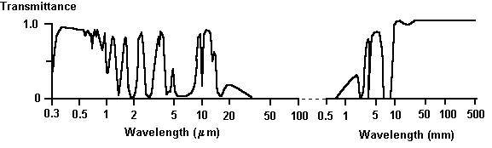

Figure 3. Atmospheric transmittance

a) How do your values for transmissivity at 1.06 µm, 0.94 µm, and 1.39 µm for the Tropical model compare with what you observed for the US Model standard atmosphere?

b) What is the most likely difference in the atmosphere that is responsible for the observed differences in transmissivity? (HINT: Why is there a change in the depth of the water band at 0.94 µm and not at 1.39 µm?)

PART II: TIR transmittance and path radiance for the standard atmosphere

Inspect the transmissivity spectrum from the US Model atmosphere for the TIR instead of the VNIR/SWIR. (It is located at the same place you accessed to download part 1.)

The following information is important for transmittance in the TIR: ozone has a strong interaction at about 9.5 µm, water and CO2 that limit the TIR window at wavelengths short of 8 µm and long of 14 µm. Ozone is a constituent of smog, but it also found high in the stratosphere. However, water is found mainly at low altitudes (<10 km).

QUESTION 3:
For the US Model Standard atmosphere, compare the transmissivity at two observer heights of 60 km and 6 km (worksheets labeled "60 km" and "6 km"):

60 km 6 km
a) What is the transmissivity at ~9.0 µm? ___________ ___________
b) What is the transmissivity at ~9.5 µm? ___________ ___________

c) Describe the difference between the transmissivity at 60 km and 6 km. Has the transmittance changed? What atmospheric property could explain your observations?

Because the atmosphere emits thermal radiation as well as absorbing and scattering it, the behavior of the path radiance term can be more complicated in the TIR than the VNIR, where thermal radiance is negligible and scattering prevails. Next we'll analyze the TIR path radiance for the tropical atmosphere. These data are available under the worksheet labeled "path rad" in the file "lab3-partII.xls".

The path radiance spectrum, like the transmissivity spectrum, is very spikey because atmospheric water is emitting radiance at discrete, but narrow bands. MODTRAN has high spectral resolution but if we averaged path radiance (or transmissivity) over a broad enough wavelength region, we would see a continuous spectrum. Note that the top and bottom of the spikes define a kind of envelope that brackets all the radiance values plotted.

QUESTION 4: (remember to specify the units you are using)
Top of envelope Base of envelope
a) What is the Path Radiance at ~9.0 µm? ____________ _____________
b) What is the Path Radiance at ~9.5 µm? ____________ _____________

PART III: Atmospheric Scattering

Rayleigh scattering refers to the scattering of light off of the molecules of the air, and can be extended to scattering from particles up to about a tenth of the wavelength of the light. It is Rayleigh scattering off the molecules of the air which gives us the blue sky. Lord Rayleigh calculated the scattered intensity from dipole scatterers much smaller than the wavelength to be:

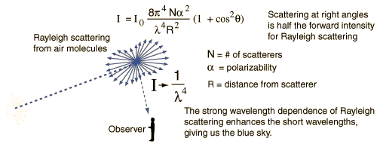

Question 5:

a) Draw a rough estimate of how you would expect atmospheric scattering to behave as a function of wavelength in the VNIR:

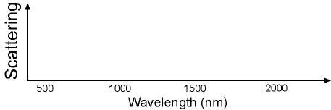

Question 6:

The two airborne MASTER scanner images below were acquired at very nearly the same time. Ignore the geometric distortions. Additional information about these images might be useful: North is basically up in the images. The images were taken at 2145 GMT, which is 1345 local standard time, on 25 August 2001. This means that the sun is illuminating the images from the lower left corner (zenith angle ~50 degrees, azimuth angle ~203 degrees east of north). The aircraft altitude was 6330 meters, and direction of flight was south to north. To answer the questions below, it will help to recall that, MASTER looks down and scans from 45 degrees to the right of the aircraft to 45 degrees to the left. So, the view angle is 45 degrees at the right and left edges of the image, and 0 in the middle.
Answer the following:

- What could be a possible source for the ‘haze’ in the right part of the top image?

- Why is there less ‘haze’ in the left part of the top image? (HINT: remember the scan angles discussed above”)

- Why is there less haze in the right part of the bottom image than in the right part of the top image?

Lake Youngs, WA (MASTER band 1, 0.462 μm)
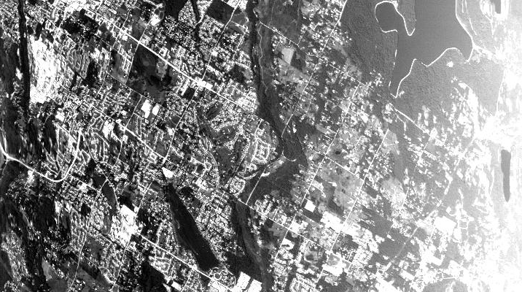

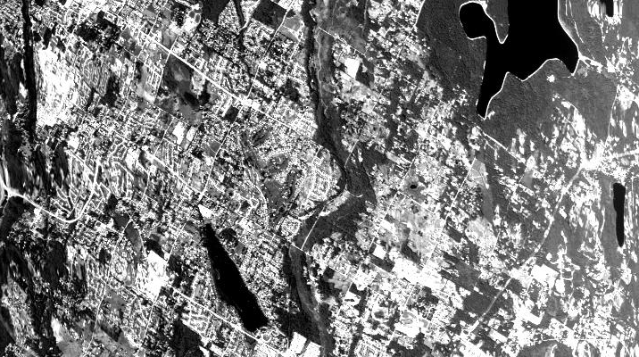Lake Youngs, WA (MASTER band 5, 0.658 μm)

