SEARCHING ASTER DATABASE

http://www.topozone.com/ - TO FIND LAT/LON FOR United States

USGS Global Visualization Viewer

http://edcdaac.usgs.gov/aster/glovis.asp

- Click on Latitude box, then enter approximate lat and lon

- Tab over to [View Images], click on ‘Enter’

This screen will come up:

- Edit Lat Lon, click on ‘Go’

*(IMP: Not all available images are shown here.)

- Figure out lat and lon ranges (East,West,North,South) for your area.
(the cursor shows coordinates at bottom of screen)

-----------------------------------------------------------------------------------------------------------------------

Go to the EOS Data Gateway for actual available images.

http://edcimswww.cr.usgs.gov/pub/imswelcome/

Click on ‘Enter as guest’ when the first screen comes up, then

This screen will come up:

- Choose ASTER under the ‘Land’ Category.

- In top box Highlight desired ‘Data Sets’, hold down ‘Ctrl’ key to select.

- Enter search area, it will find any images that have any part in that range.

- If no Date/Time range is entered, all images found will be shown

- Under ‘Choose Additional Options’, change maximum number to at least 500.

- Click ‘Start Search’

Here's a japanese aster website where you can get manuals and info:

http://www.gds.aster.ersdac.or.jp/gds_www2002/index_e.html

Here's the JPL ASTER homepage site:

http://asterweb.jpl.nasa.gov/

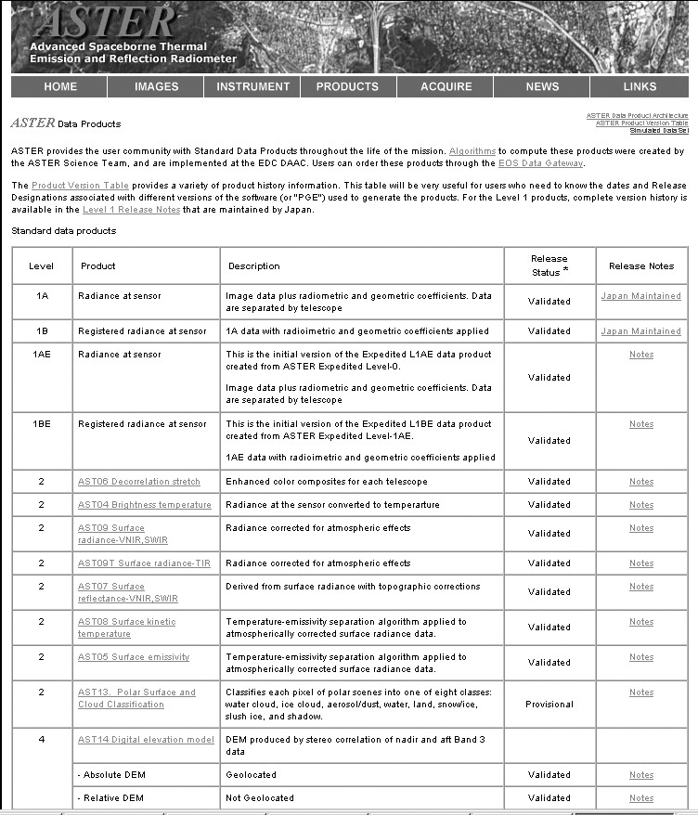

http://www.gds.aster.ersdac.or.jp/gds_www2002/libraly_e/set_lib.html

